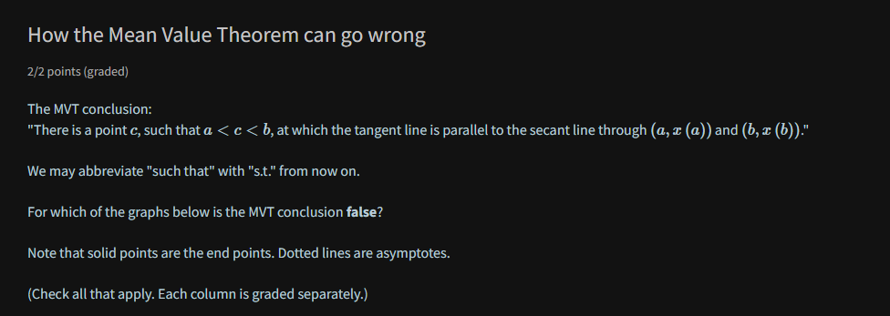

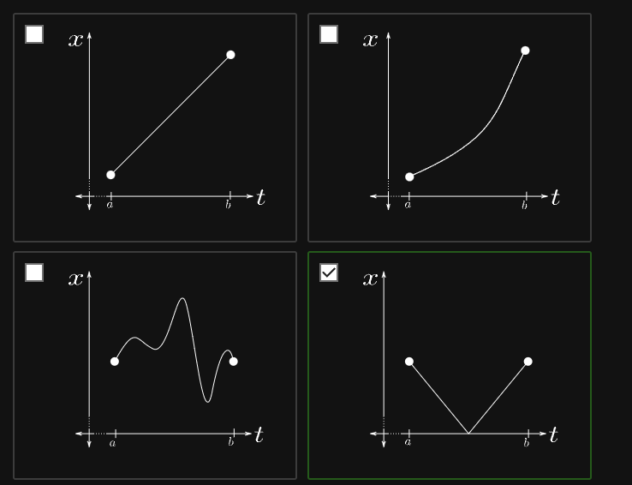

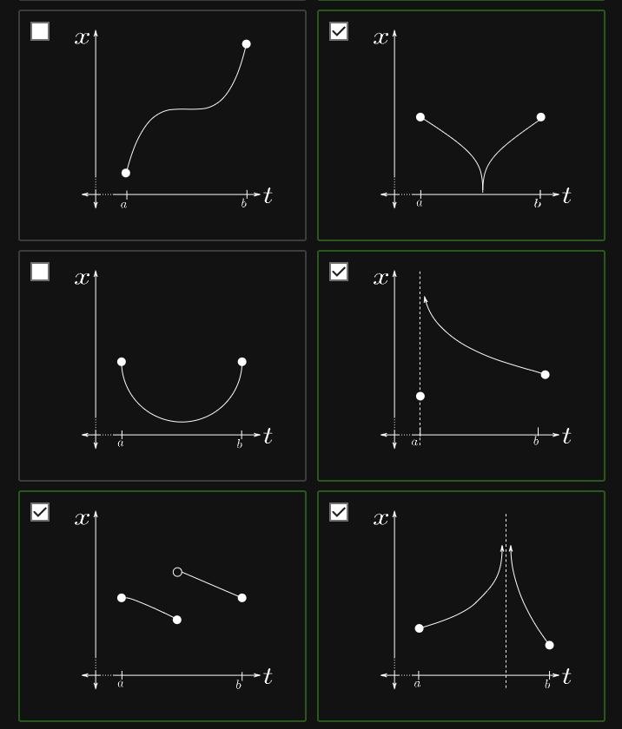

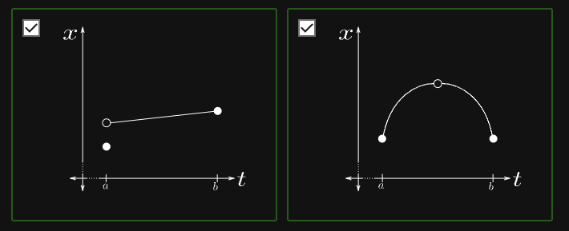

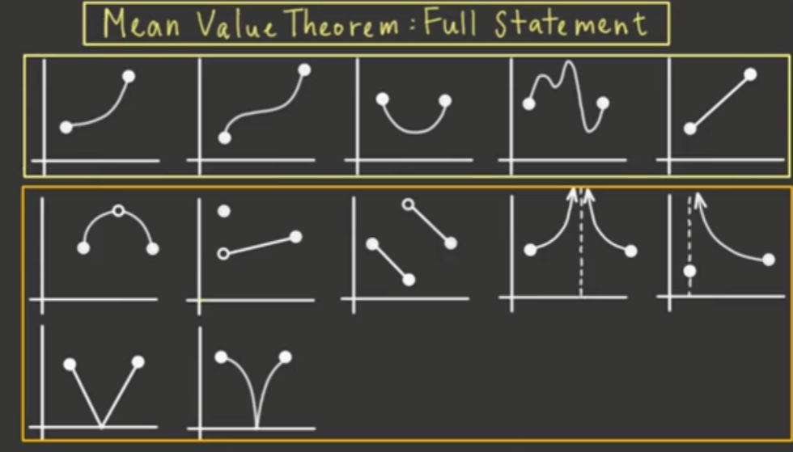

* Upper row – success
* Lower row – failed

FAILING

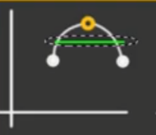 undefined function where it tangents

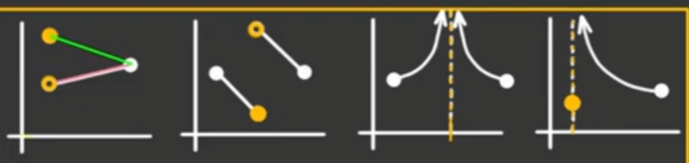

* No relationship because of the discontinuities



* All of these are NOT differentiable

SUCCESS

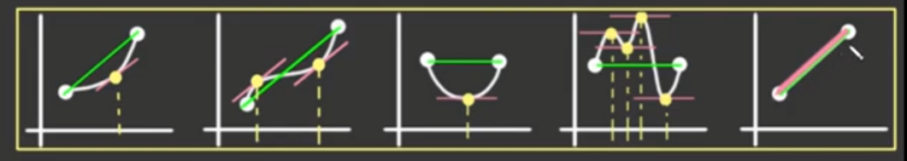

* Last item has every point c!
* All of these are differentiable and continuous

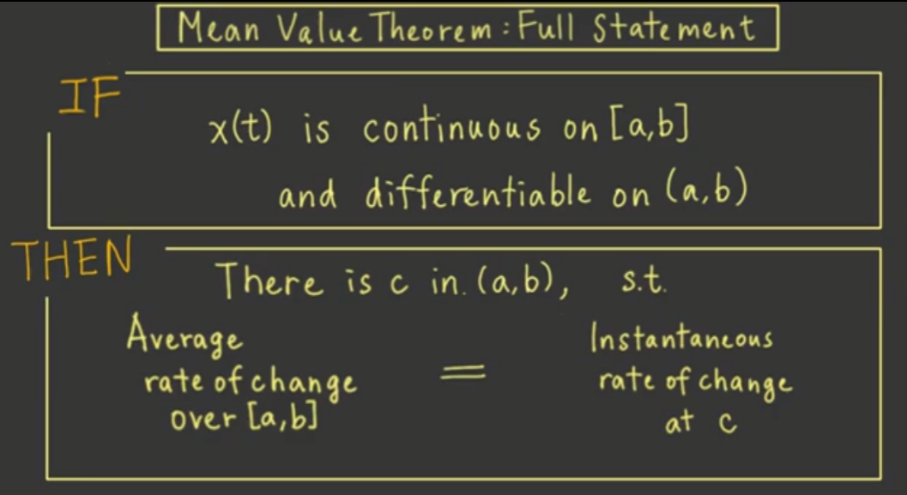

Formula version

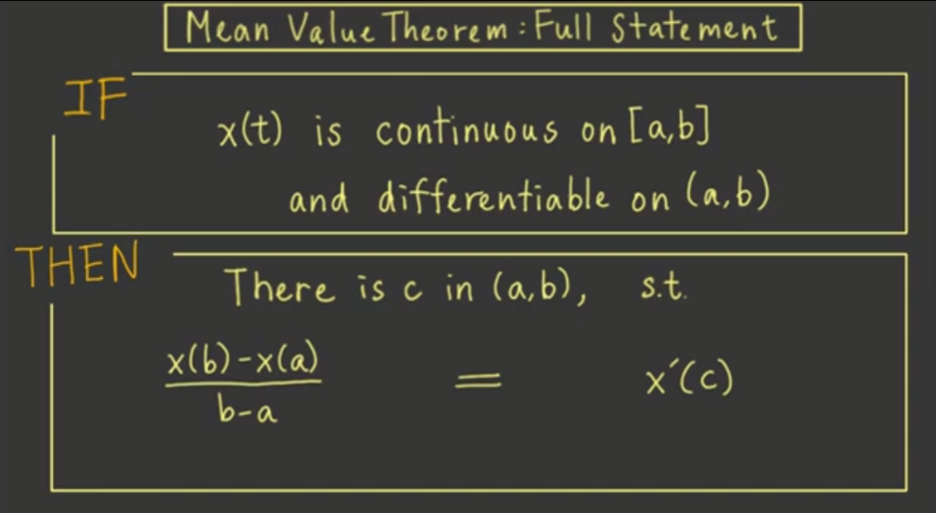

* Note: differentiable only on the open interval of (a, b)
  + Meaning it doesn’t have to be differentiable on the endpoints itself